# QlikView Self-Service deployment!!

Prithwish Banerjee

Java & Web Technologies

### QlikView is an in-memory, business discovery tool. Which converts data into knowledge. QlikView is a Business Intelligence application that helps organizations big and small in data discovery. Now the concept of QlikView Self-Service deployment is about giving people (QlikView developers) permissions to deploy specific applications (QlikView) to specific environments (Dev to Prod).

## Pre-requisites for the Process

You will need the following components installed:

* Command Prompt
* Windows PowerShell ISE

Once your configuration is complete, you can start the writing the PowerShell script.

How to use/Operation

1. You must create folders as per the container structure in the Production, where peoples (Developers) can place file and folders accordingly.
2. Go to the location: **\\<server-address \<Folder-name>\QlikView Deployment-Inter**

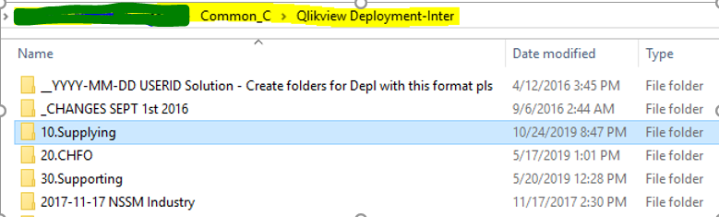

**Note:** Here, we are creating one folder (10. Supplying). You can create your own folders. In order to execute, please follow the same folders structures.

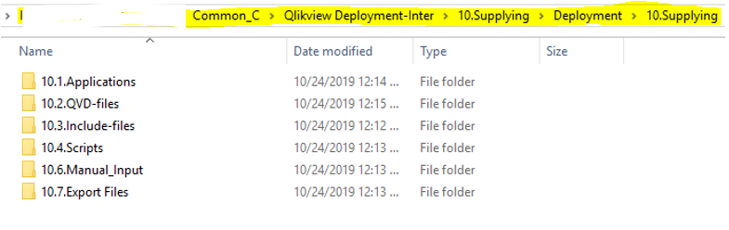

**Note:** You need to create one “**Deployment**” under your created folder (Here we create 10. Supplying folder).

1. After placing the file and folders, people (developer) need to run the script named “**Deploy.cmd**” by double click from the below location as shown:

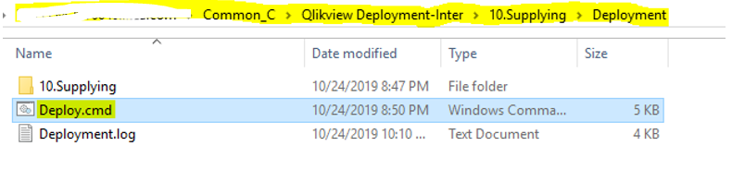

1. As soon as people (developers) triggered the script, it will be going to ask some **Boolean input i.e. Y/N**.

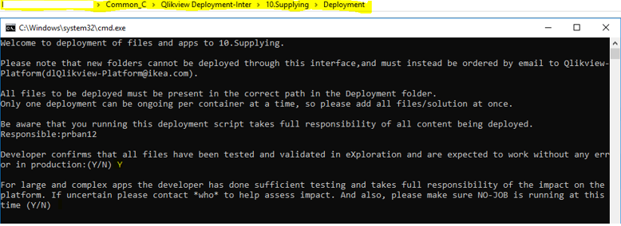

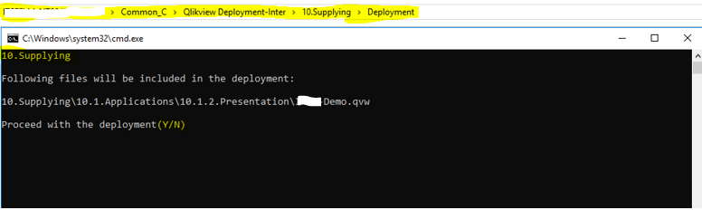

1. Once all the conditions are fulfilled it will generate a “**parameter.txt**” file which contain all the information related to deployment such as container name, people (developers)short id of developer, location and name of file and folders that will be deployed.

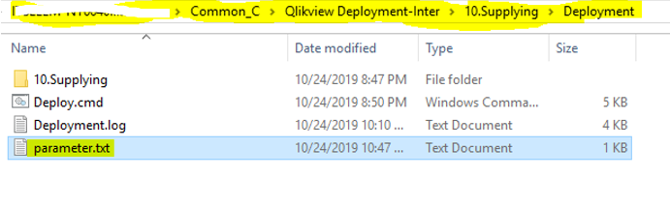

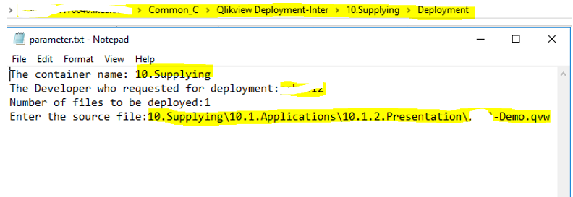

**Note:** Here, people (Developers) actions end.

1. We have scheduled another script from server through task scheduler which runs in some period and deployed all the files and folders placed by the people (Developer) at the development location.
2. Now, you need to trigger that scripts to check whether the files are deployed into production from development shared location or not
3. Rollback is possible, means it will take backup for any existing application.
4. Corresponding logs are there, so that you can check Developer and Admin logs in order to get further clarification.

**Note:** In the SolutionNames.txt file, you must add your container name. ***Ex:*** we have added 10. Supplying container name in here.

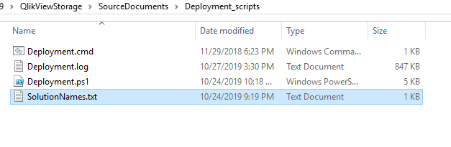

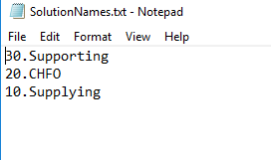

1. Finally, you need to trigger the Deployment.cmd file.

**Note:** If you are not scheduling the Deployment.cmd file from server through Task Scheduler. Then you can trigger that Deployment.cmd script.

